

# **Shadow Stride**

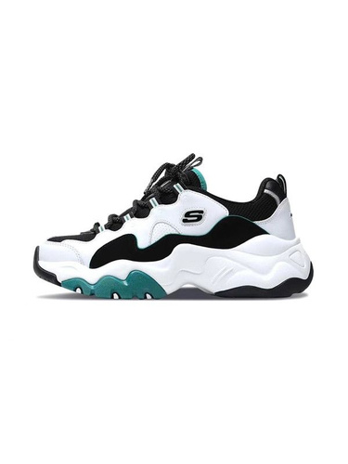

Product Details:

Color: The Skechers Shadow Stride shoes feature a sleek and modern color palette with deep charcoal, light blue-gray.

Sole: The sole is divided into three distinct sections: the bottom front is dark teal, the center is soft gray, and the back bottom is dark slate.

Material: Crafted from premium synthetic materials and breathable textiles for durability and style.

Closure: Secure lace-up closure system for a personalized and snug fit.

Branding: Skechers logo subtly embossed on the tongue and side, showcasing the brand's authenticity and heritage.

Comfort: Padded collar and cushioned insole provide exceptional comfort, making them suitable for all-day wear.

Style: The Skechers Shadow Stride shoes offer a unique and stylish design, blending modern aesthetics with athletic functionality.

Occasion: Versatile enough for various occasions, from casual outings to urban adventures.

Versatility: Pair with jeans, joggers, or even a casual dress for a trendy and sophisticated look that sets you apart from the crowd.